

**Introduction to AutoAI, Data Refinery and Watson Studio Deploy (WML) Hands-on Lab :   
Pre-work**

Tamara Tatian, IBM Cloud Pak for Data Technical Sales EMEA

Lab: AutoML in Watson Studio

*19.11.2021*

*Author: Elena Lowery elowery@us.ibm.com*

© 2021 IBM Corporation

# Overview

To complete the Introduction to AutoAI, Data Refinery and Watson Studio Deploy (WML) Hands-on Lab, you will be using IBM Cloud Pak for Data as-a-Service (CPDaaS).

Pre-requisites:

* IBM ID
* IBM Cloud Account
* CPDaaS account – provisioned services: Watson Studio, Watson Machine Learning, Cloud Object Storage.

The below guide will take you through all the steps required to get your IBM ID, IBM Cloud Account and CPDaaS subscription (Free “Lite” plans only will be used). The whole process should not take more than 15-20 minutes.

Please note that you will likely need to provide credit card details to verify your identity and activate your Cloud account – however, we will only be using Lite (free) plans for all the required services so you should not incur any charges.

If you already have an IBM ID and/or IBM Cloud Account – please skip to page 4 – Setting up your CPDaaS.

If you already have a CPDaaS subscription – please make sure you have Watson Studio and Watson Machine Learning services provisioned for the lab, in the same region.

# Getting your IBM ID and IBM Cloud Account

Please follow the instructions from the following page: <https://cloud.ibm.com/docs/account?topic=account-account-getting-started>

For example, if you already have an IBM ID but not your IBM Cloud Account the process will look similar to this:

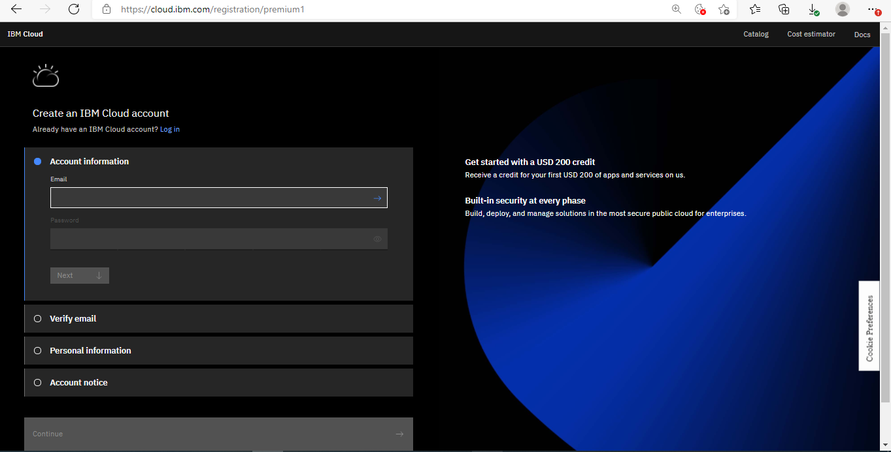

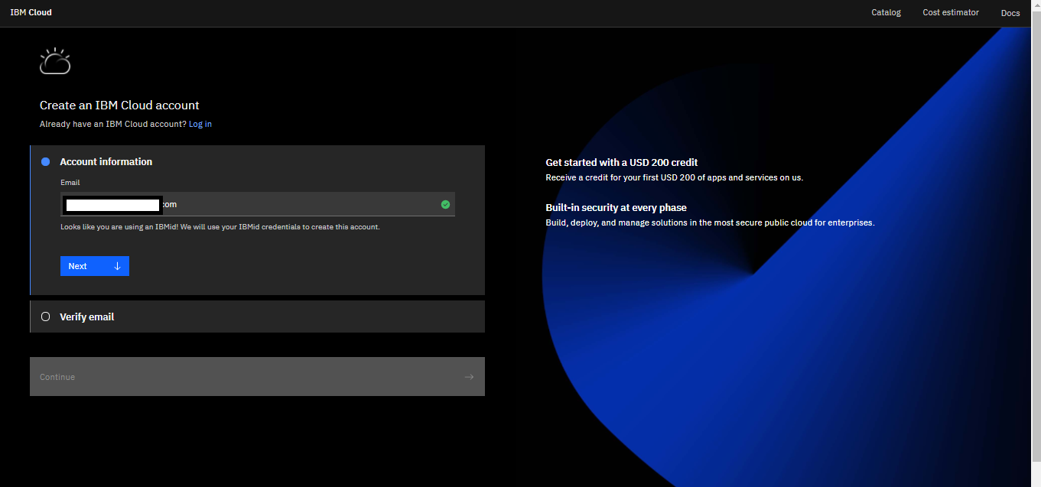

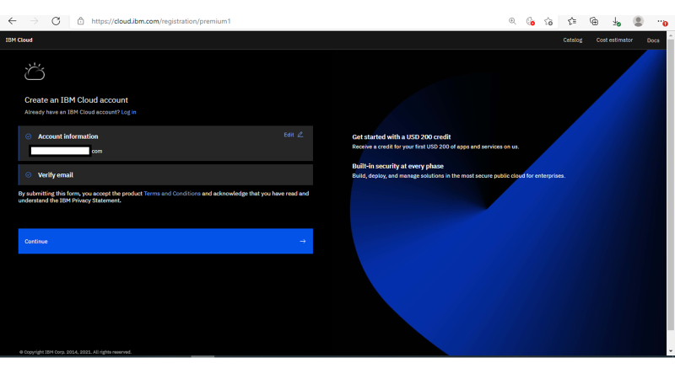

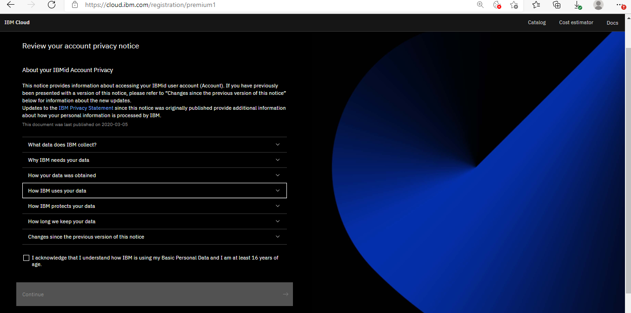

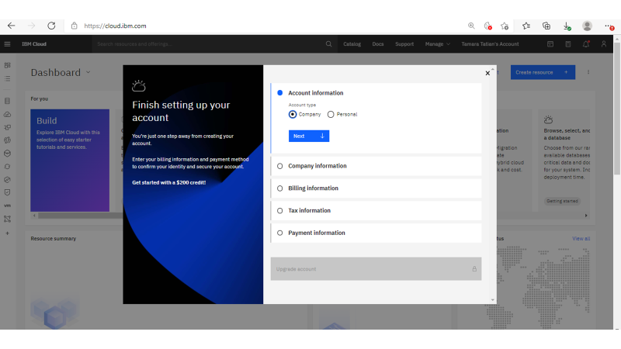

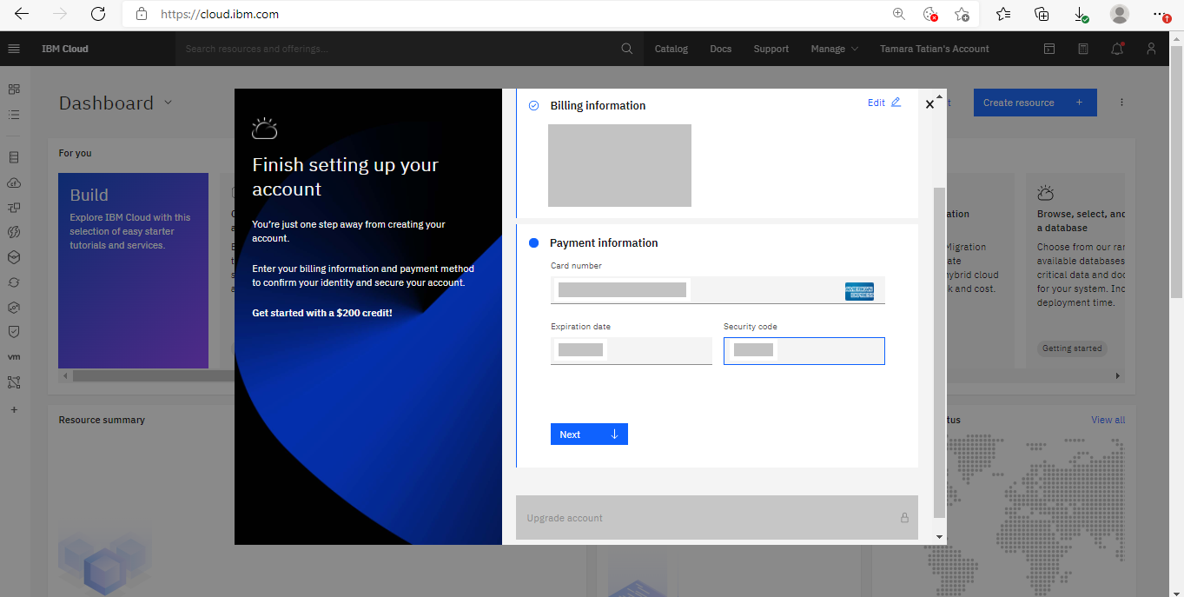

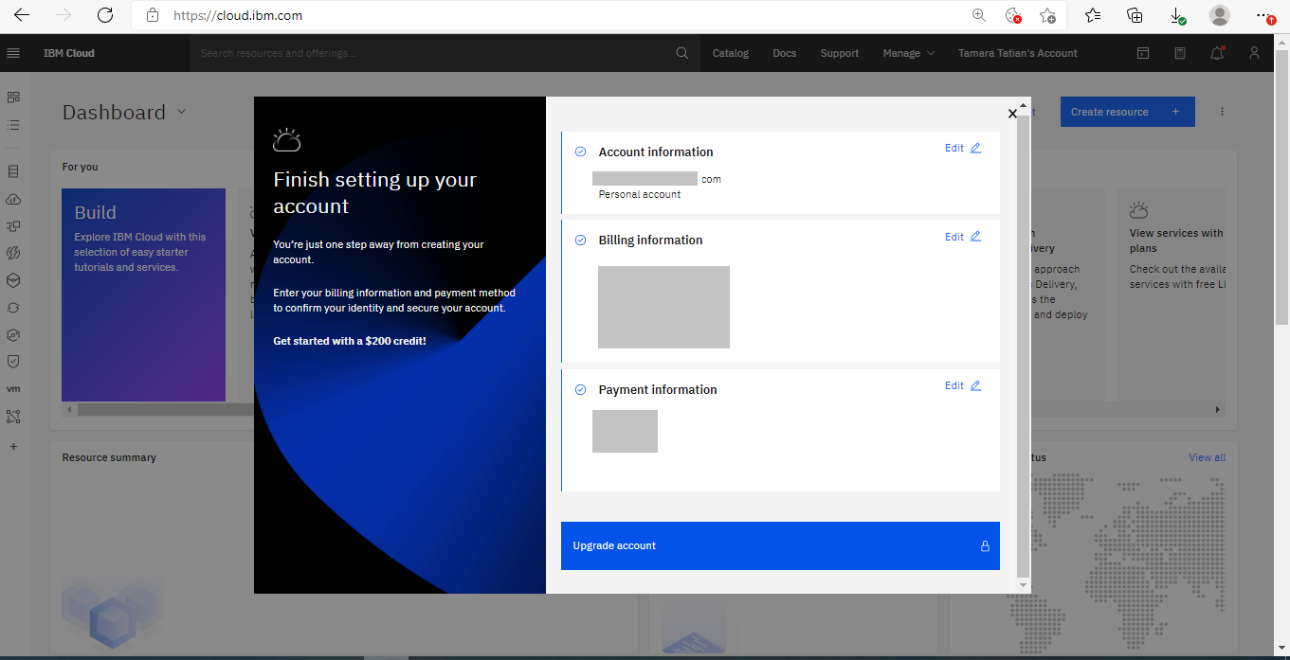

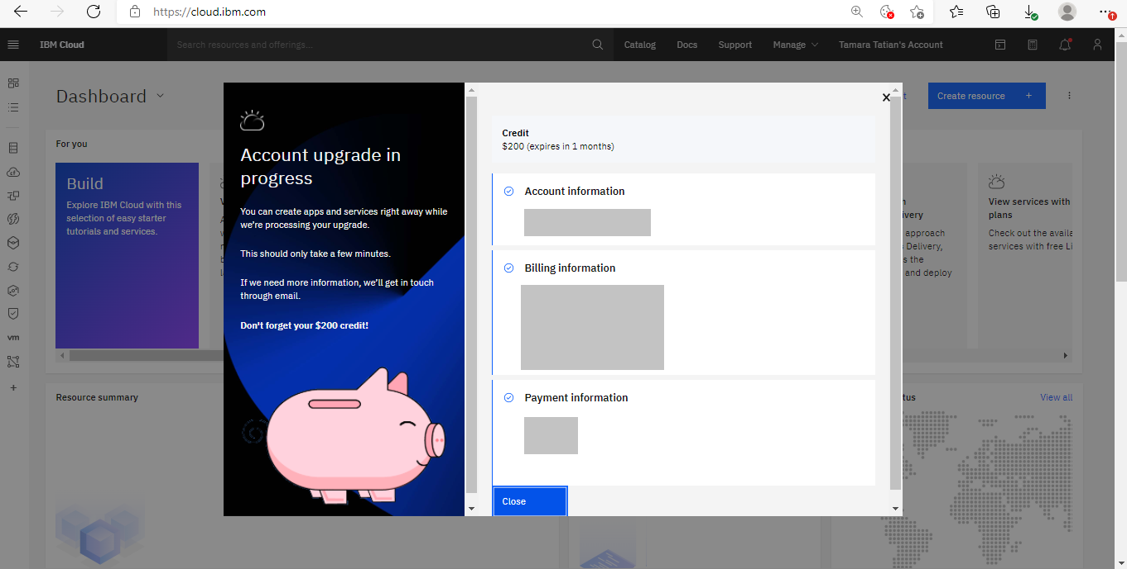

Once you set up your IBM Cloud account, please move to the next step – setting up your CPDaaS.

# Setting up your CPDaaS

Please log in to your IBM Cloud Account: <https://cloud.ibm.com/>

From your account Dashboard, click Create Resource.

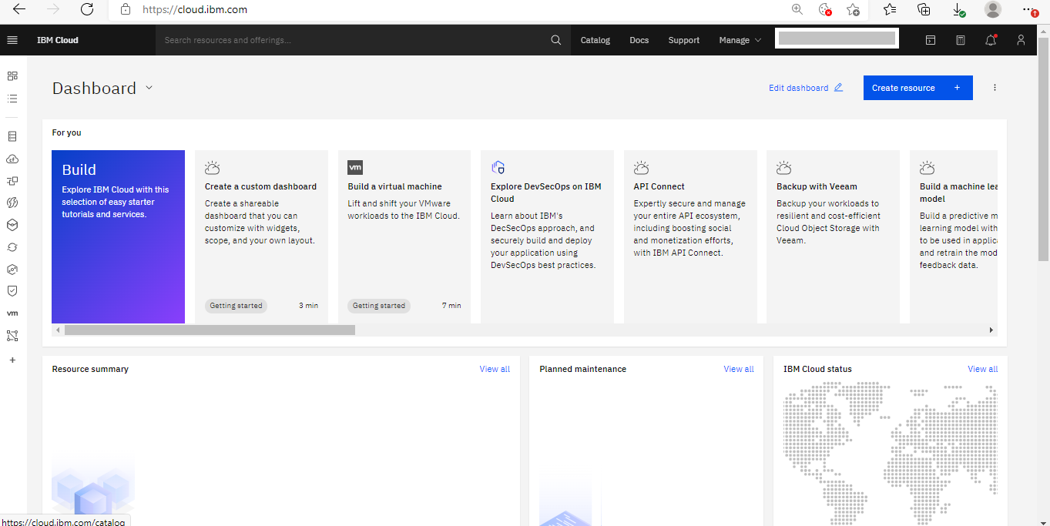

Search for Watson Studio

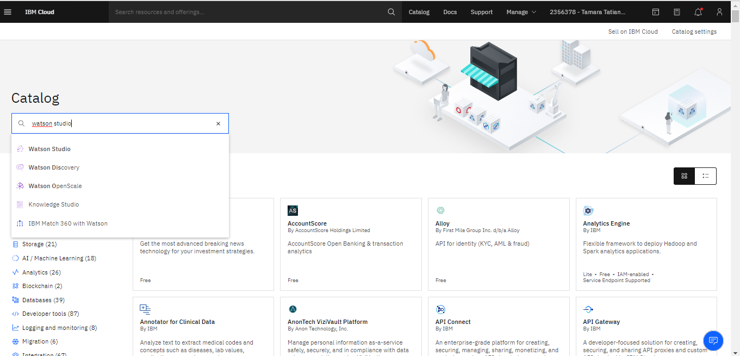

Provision (create) a Lite plan in Frankfurt (do not forget to read and accept the Terms).

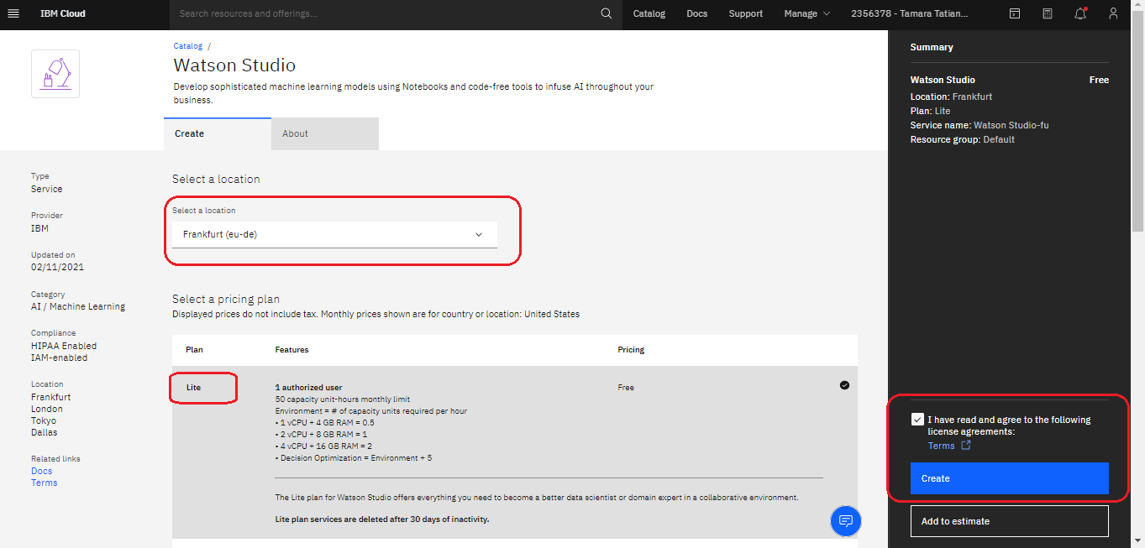

Next, search for Watson Machine Learning using the search bar on top of the screen

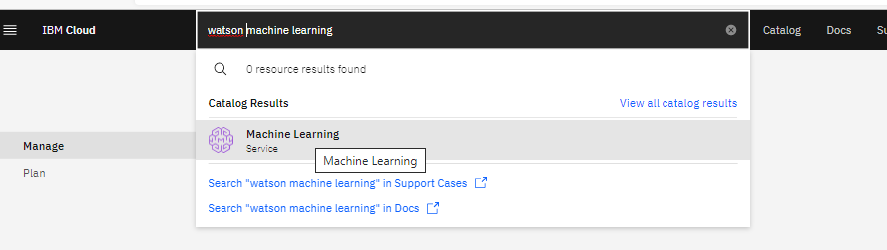

Provision a Lite plan in Frankfurt

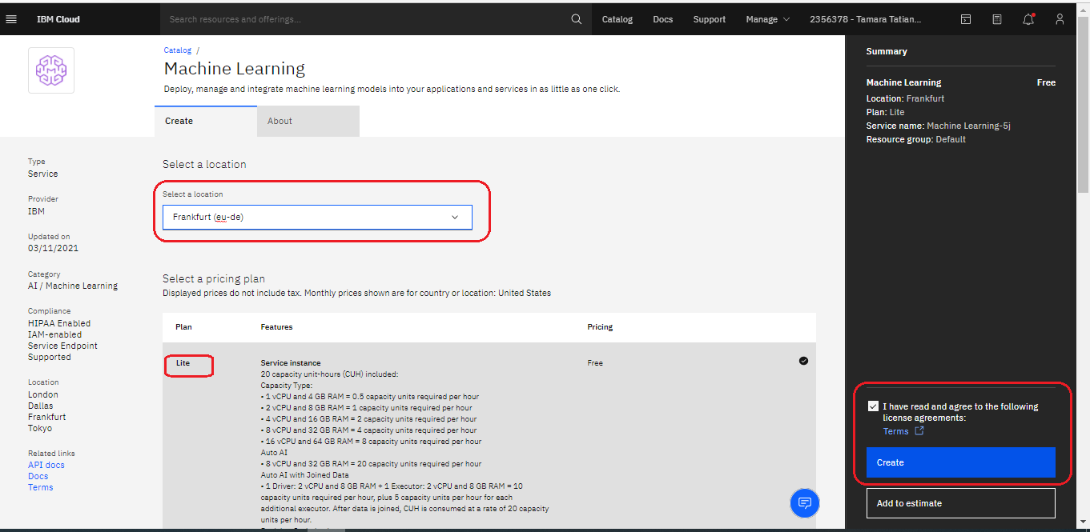

Repeat for Cloud Object Storage – go with the defaults for the Lite plan.

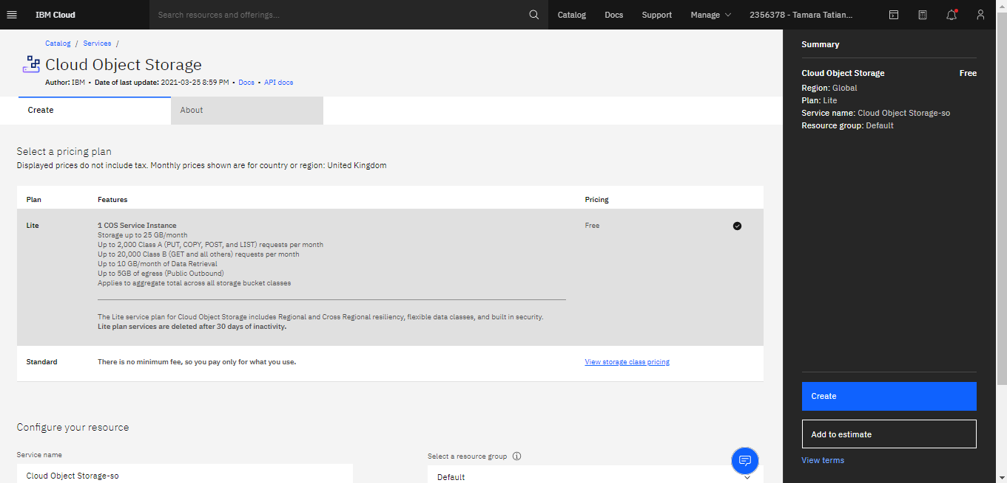

Next, click on the hamburger menu (top left of the screen) and select Resource List. You should be able to see all the three provisioned services, as follows.

Click on your Watson Studio service.

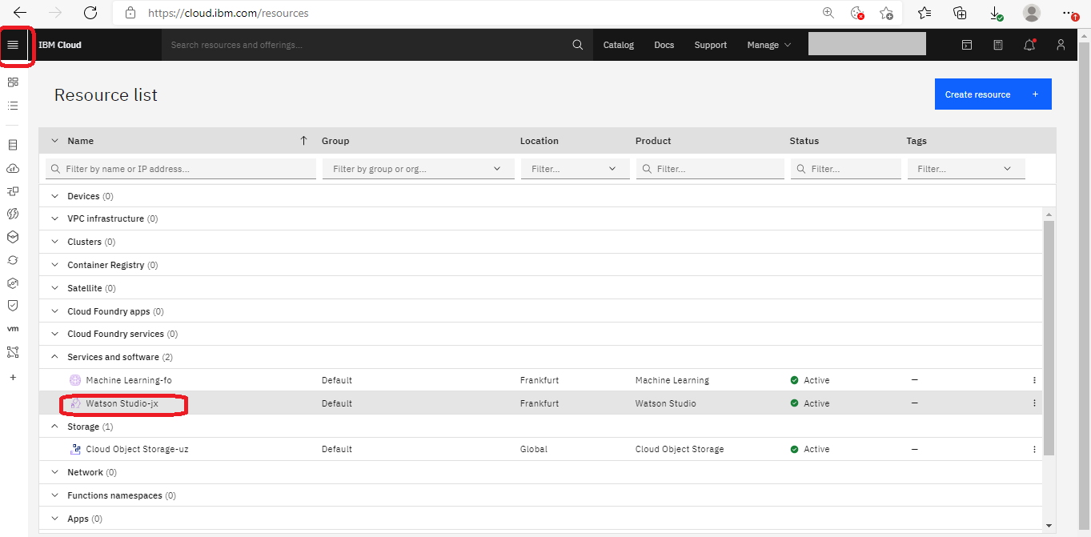

Click “Launch in Cloud Pak for Data”

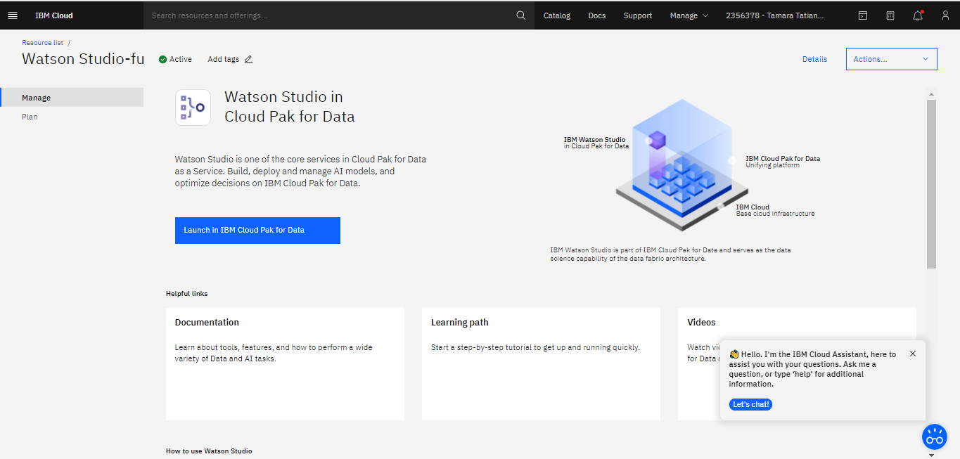

You will see this screen – once the set up completes, click Go to Watson Studio

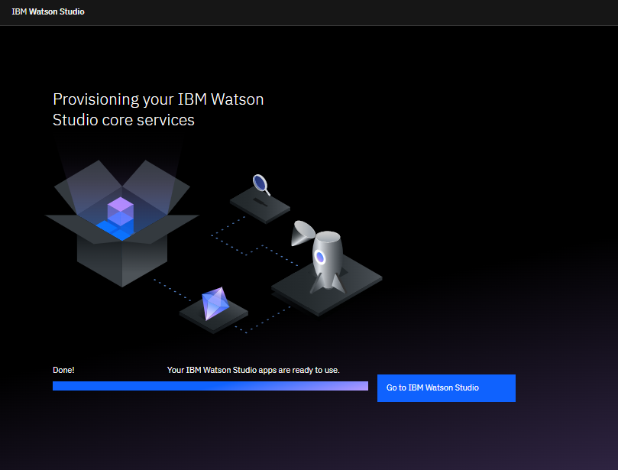

From this point onward, you will also be able to log in to your CPDaaS at this URL directly: <https://eu-de.dataplatform.cloud.ibm.com/>

Finally, let’s make sure all of our services talk to each other within our lab project. On your home page, click Create a Project link (or New Project button)

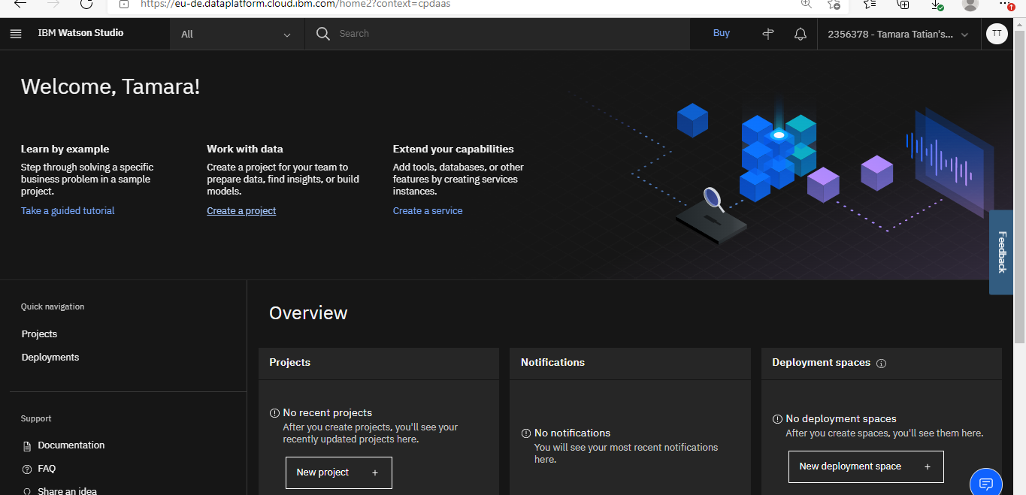

Create an empty project called “My AutoAI experiment”. Your Object storage should be picked up automatically. If you have more than one of those against your account, please pick whichever one is most relevant.

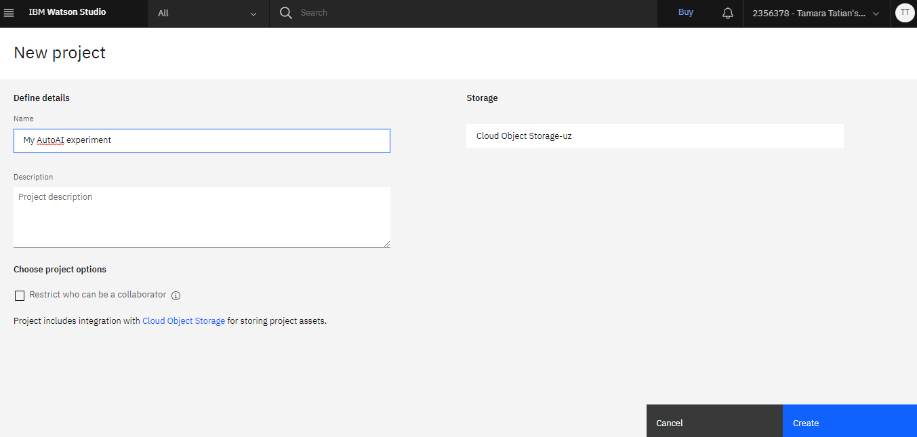

Finally, associate your Machine Learning service with the project.

Go to the Manage tab and open Services & integrations

Click on Associate service

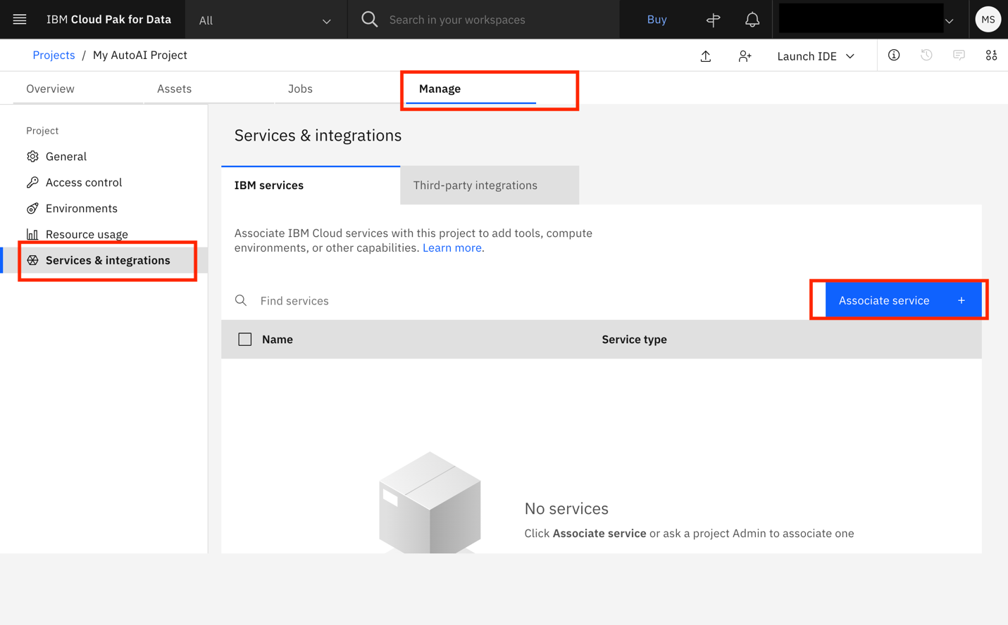

Select and associate your Machine Learning service on the next screen.

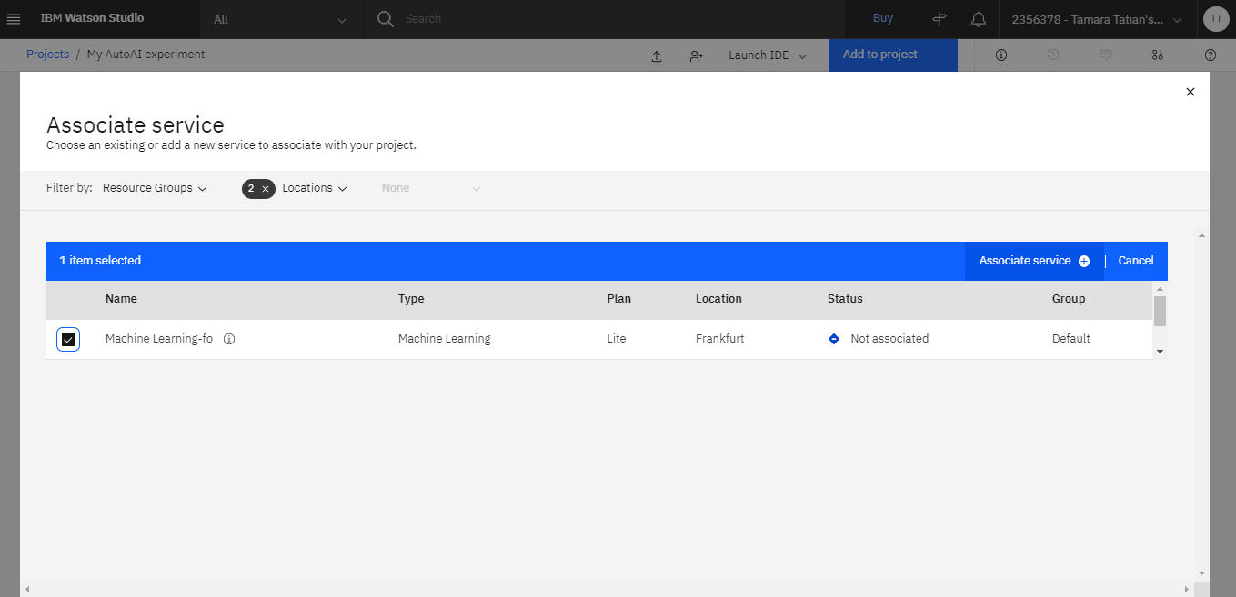

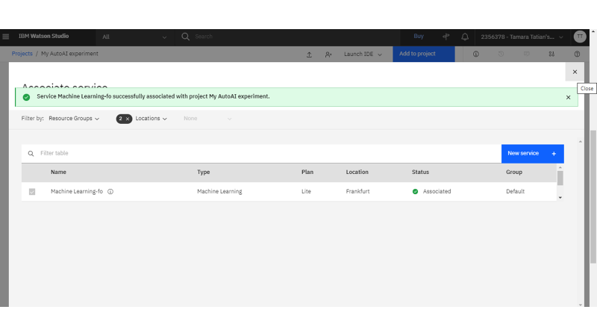

That is it – you are now ready for the hands-on lab.

